Eyeconic – Glasses Shop Management System

Use-Case Specification: M01 - Cancel Order (User)

Version 1.0

Revision History

|  |  |  |  |
| --- | --- | --- | --- |
| **Date** | **Version** | **Description** | **Author** |
| 05/11/2019 | 1.0 | Start creating use case | Hoàng Tiến Long |
|  |  |  |  |
|  |  |  |  |
|  |  |  |  |

Table of Contents

1. Cancel Order 4

1.1 Brief Description 4

1.2 Actor 4

2. Flow of Events 4

2.1 Basic Flow 4

2.2 Exception 5

2.2.1 Existed order 5

3. Special Requirements 5

4. Preconditions 5

4.1 Login 5

5. Postconditions 5

6. Extension Points 5

Use-Case Specification: Cancel Order

# Cancel Order

## Brief Description

This use case defines the step of cancelling order from the user.

Customer can easily cancel the order by clicking the cancel button in management order.

## Actor

User.

# Flow of Events

## Basic Flow

User selects the Order wanted to cancel. The order will be canceled from the database due to user. The system displays the updated management parameter value and logs the change.

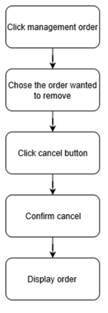

***Basic flow of cancelling order***

Step 1: Click management order.

Step 2: Choose order that wanted to cancel.

Step 3: Click cancel order button.

Step 4: Confirm cancelling order.

Step 5: Display canceled order.

## Exception

### Existed order

If the order(s) are not confirmed successful or not existed then could not cancel the order

# Special Requirements

No Special Requirements

# Preconditions

## Login

User must already login as the customer of the website.

Accuracy is required when user want to cancel the order.

# Postconditions

# Extension Points

No extension points.